Resources for Parents
Jan 2021

Websites:

Parenting - Focus on the Family
Parenting | Desiring God
Resources | Christian Counseling & Educational Foundation (ccef.org)
Parenting Books, DVDs &amp; Packages | Love &amp; Logic® – Love and Logic Institute, Inc
New City Catechism (App available)

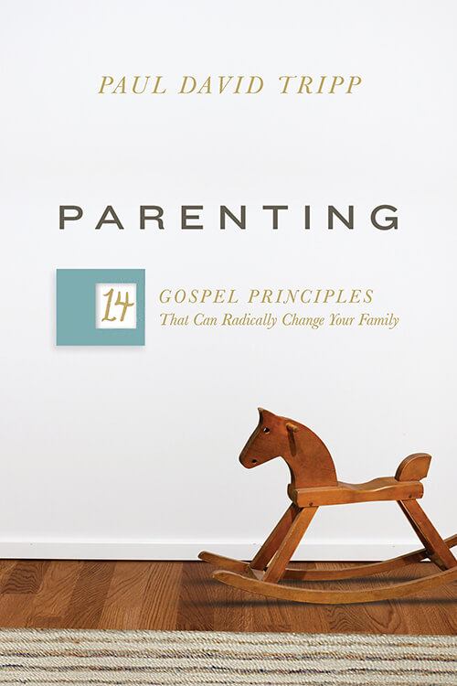
Books:
